**Team Name:**

Raleigh International

**Team Members:**

Connor Albers

Brianna Patterson

Katelyn Dawkins

Wright Herndon

Cade Brewster

Connor Albers, Brianna Patterson, Katelyn Dawkins, Wright Herndon, & Cade Brewster

**City:**

Raleigh NC

**Area:**

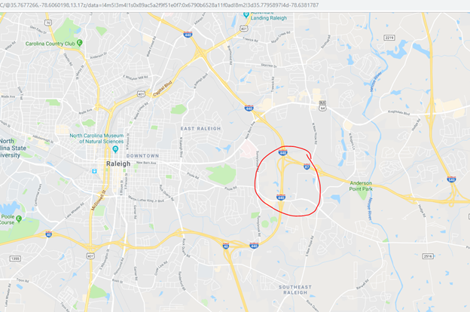

**Destinations:**

Paris

London

Amsterdam

Athens

Berlin

Chicago

New York

Detroit

San Francisco

Houston

**Airlines:**

American Airlines

Chicago

New York

Detroit

San Francisco

Houston

Delta

Chicago

New York

Houston

British Airways

Paris

London

Southwest

Chicago

New York

Detroit

San Francisco

Houston

Lufthansa

Paris

London

Amsterdam

Athens

Berlin

JetBlue

Paris

London

Chicago

New York

Air France

Paris

London

**Similar airports:**

**Tulsa(TUL):** On the homepage, it keeps important information simple. They have flight lookup, parking information, and the weather displayed. Below this, they have a map of all non-stop destinations they fly to. They also have simple nav with a drop down for more detail.

**Los Angeles(LAX)**: Homepage is very simple, big buttons that link to arrivals, departures, and maps.

**Chicago O’Hare (ORD):** On the homepage it has all important information. It has a flight lookup, parking information, parking lot capacity. Below this section there is a spot for any new article that is important information about the airport. They also have a couple of links that can take you to other parts of the website such as a map showing all the places to eat and where the tsa checkpoints are in each airport.

**George Bush Intercontinental(IAH)**: The IAH website contains some really useful statistics such as current wait times for nearly everything, parking lot capacity percentages, and details about pricing and timing of restaurants. In addition, they use news-style posts to give updates on the airport. The site also uses very clean looking CSS cards as image links.

**Hartsfield Jackson (ATL):** The website for the Atlanta airport has a very good map of the inside of the airport. The map is easy to use, see and zoom in to different areas. The color scheme is also good because it is fairly simple and that is shown throughout the website.

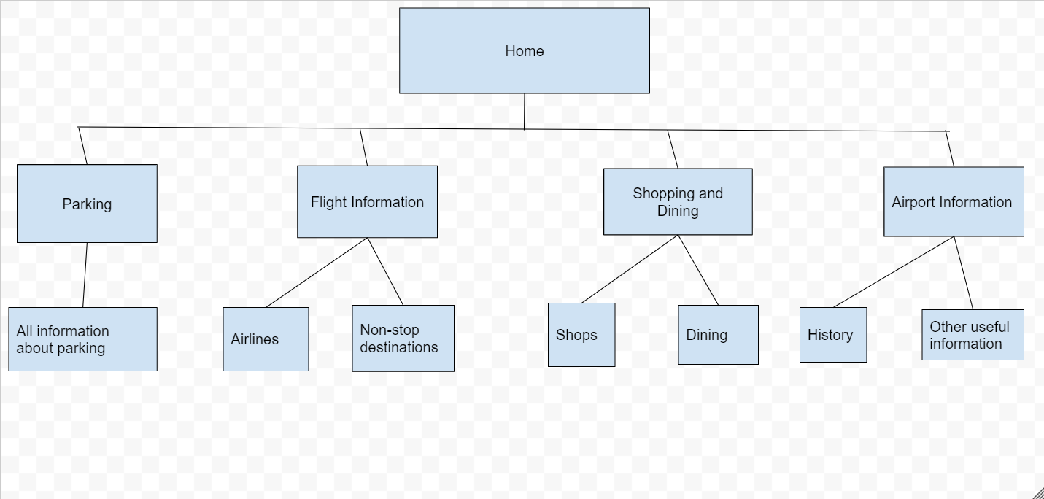

***Stuff***

Colors:

* #204787 navy
* #89cff0 baby blue
* #696e70 gray